**Homework**

**FIU Spring 2017**

**ESI 6455 Advanced Engineering Project Management**

**Chapter 6 P197:E19**

**Student Name: Yezehao Huai**

**Student Panther ID: 5965823**

**P197 19. Given the following information, draw the project network. Compute the early, late, and slack times for the project network. Which activities on the critical path have only the start or finish of the activity on the critical path?**

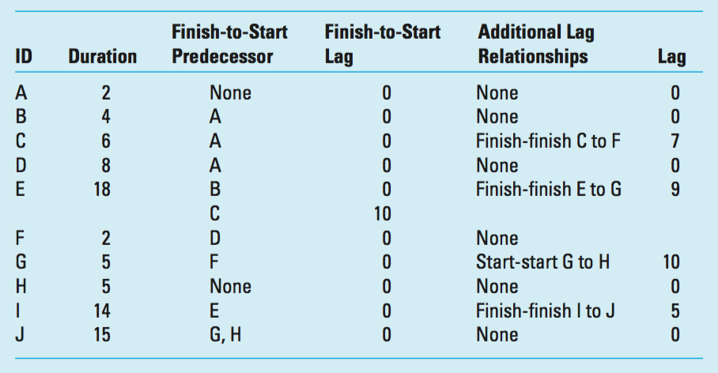

|  |  |  |
| --- | --- | --- |
| 2 | B | 6 |
| 12 |  | 12 |
| 14 | 4 | 18 |

|  |  |  |
| --- | --- | --- |
| 18 | E | 36 |
| 0 |  | 0 |
| 18 | 18 | 36 |

|  |  |  |
| --- | --- | --- |
| 36 | I | 50 |
| 5 |  | 5 |
| 41 | 14 | 55 |

|  |  |  |
| --- | --- | --- |
| 0 | A | 2 |
| 0 |  | 0 |
| 0 | 2 | 2 |

|  |  |  |
| --- | --- | --- |
| 2 | C | 8 |
| 0 |  | 0 |
| 2 | 6 | 8 |

|  |  |  |
| --- | --- | --- |
| Legend | | |
| ES | ID | EF |
| SL |  | SL |
| LS | DUR | LF |

|  |  |  |
| --- | --- | --- |
| 2 | D | 10 |
| 18 |  | 18 |
| 20 | 8 | 28 |

|  |  |  |
| --- | --- | --- |
| 10 | F | 15 |
| 18 |  | 15 |
| 28 | 2 | 30 |

|  |  |  |
| --- | --- | --- |
| 15 | G | 45 |
| 15 |  | 0 |
| 30 | 5 | 45 |

|  |  |  |
| --- | --- | --- |
| 25 | H | 30 |
| 15 |  | 15 |
| 40 | 5 | 45 |

|  |  |  |
| --- | --- | --- |
| 45 | J | 60 |
| 0 |  | 0 |
| 45 | 15 | 60 |